Data Flow Diagrams & User Stories

|  |  |
| --- | --- |
| Date | 19 November 2022 |
| Team ID | PNT2022TMID50196 |
| Project Name | Exploratory Analysis of RainFall Data in India for Agriculture |
| Maximum Marks | 4 Marks |

**Data Flow Diagrams:**

A Data Flow Diagram (DFD) is a traditional visual representation of the information flows within a system. A neat and clear DFD can depict the right amount of the system requirement graphically. It shows how data enters and leaves the system, what changes the information, and where data is stored.

# 0 – LEVEL DATA FLOW DIAGRAM:

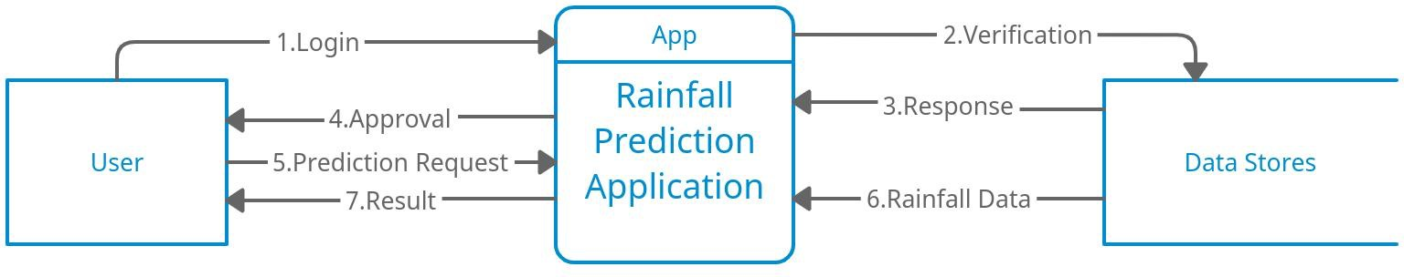

1. User logins to the application using his or her credentials.
2. Verification of credentials is done using the data stored in the database.
3. Application getting the response from the database.
4. Approval of login or else an error message for incorrect credentials.
5. Prediction request for the particular area or region is sent by the user.
6. Application getting the dataset of previous year/month/day rainfall data from the database/cloud.
7. The result has been sent to the user as an output after the prediction has been made using the machine learning model in the application.

# – LEVEL DATA FLOW DIAGRAM:

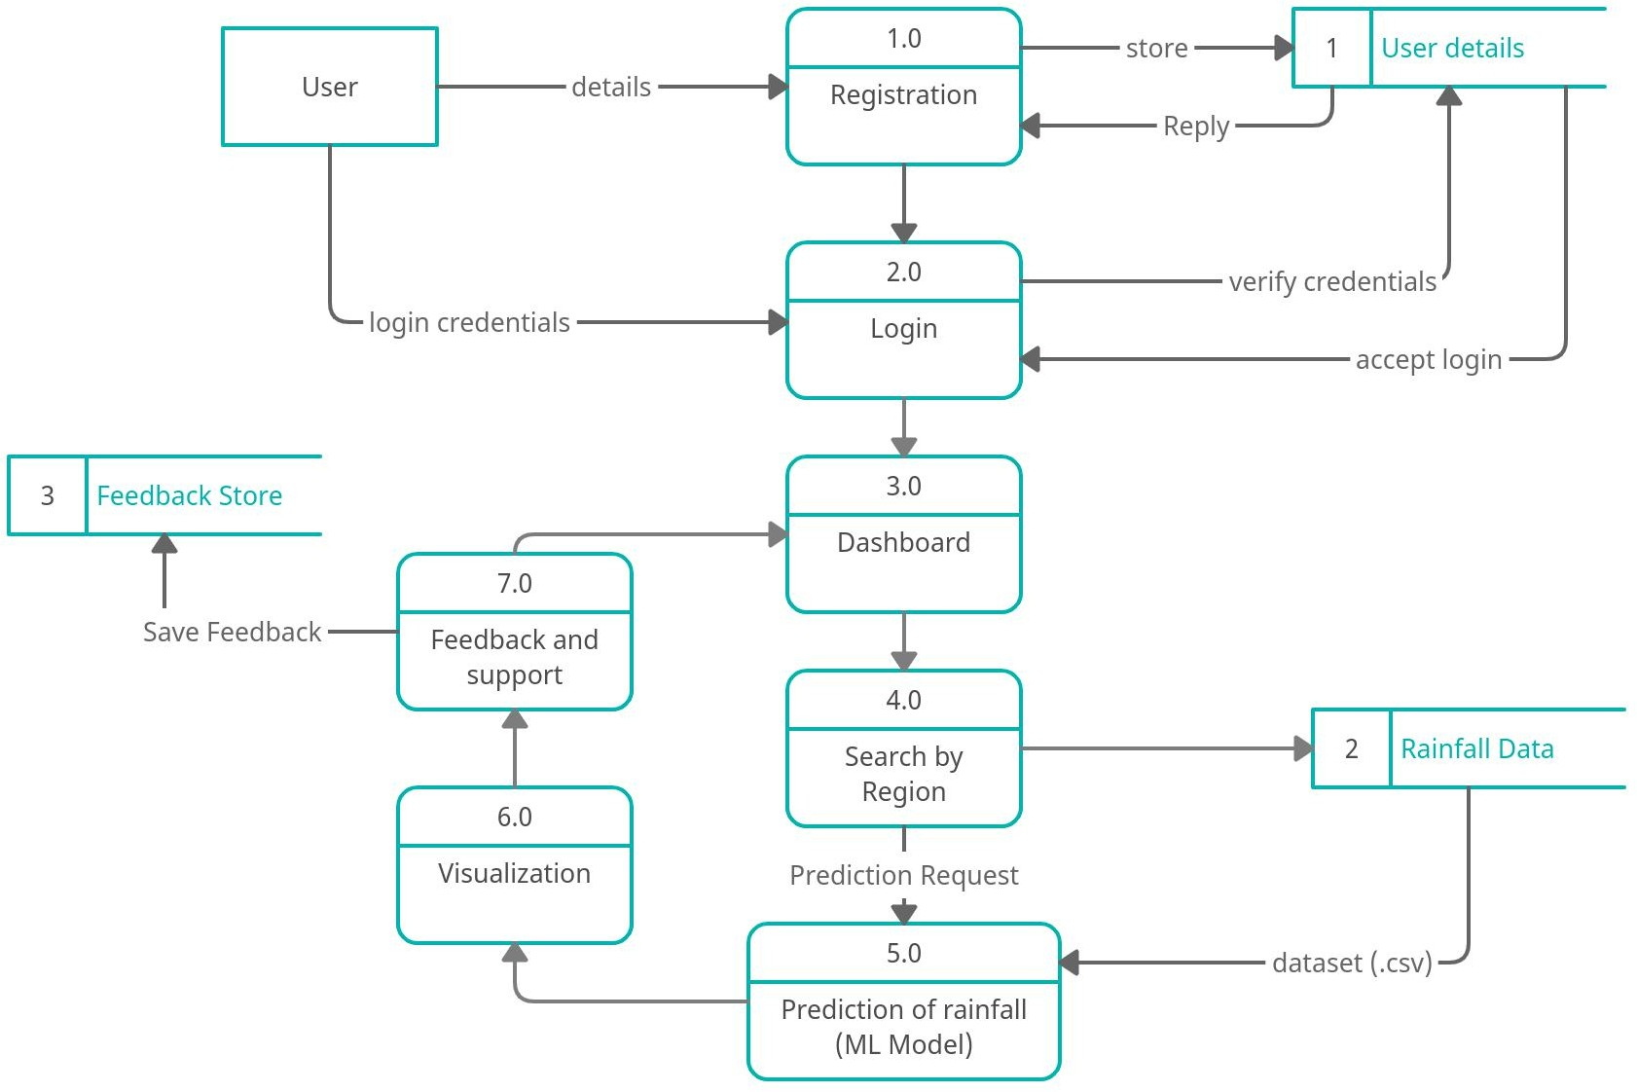

1. **– LEVEL DATA FLOW DIAGRAM:**

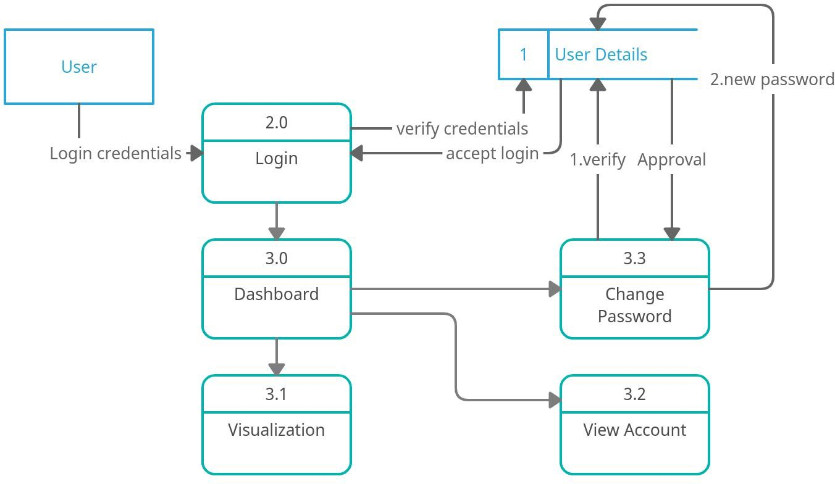

# User Stories:

*The user stories for the product are listed below*

|  |  |  |  |  |  |  |
| --- | --- | --- | --- | --- | --- | --- |
| **User Type** | **Functional**  **Requirement (Epic)** | **User Story Number** | **User Story / Task** | **Acceptance criteria** | **Priority** | **Release** |
| User in Website | Registration | USN-1 | User can register for the application by entering his or her email, password, and confirming  the password. | Account specific tasks and actions can be performed | High | Sprint-1 |
|  |  | USN-2 | User will receive confirmation  email or message once registered for the application | Verify the registered account | High | Sprint-1 |
|  |  | USN-3 | Validation of the user can be done directly using email or OTP | Account validated and got access to profile dashboard | Medium | Sprint-1 |
|  | Login | USN-4 | Enter the username and password to login to the application | Right account credentials should be entered | High | Sprint-1 |
|  |  | USN-5 | The existing credentials should be used for login on multiple systems |  | Medium | Sprint-1 |
|  | Dashboard | USN-6 | User can search for the region  where he/she wants to know the prediction of rainfall | Searching for the region in India will be accepted only | High | Sprint-2 |
|  |  | USN-7 | User can view the visualization of the rainfall data for a specific region in India or for a specific time  period |  | Medium | Sprint-2 |
|  |  | USN-8 | User can change his/her password  and can view the account details and search history | Verification will be required  and new password should be entered | High | Sprint-2 |
|  |  | USN-9 | The prediction or analysis request can be asked for the desired region for future or past events  respectively |  | High | Sprint-2 |

|  |  |  |  |  |  |  |
| --- | --- | --- | --- | --- | --- | --- |
| **User Type** | **Functional Requirement**  **(Epic)** | **User Story Number** | **User Story / Task** | **Acceptance criteria** | **Priority** | **Release** |
|  |  | USN-10 | User can give the feedback on the  accuracy of the prediction and on the user interface |  | High | Sprint-3 |
| Support Team | Support | USN-11 | Responds to user queries via telephone, email etc. | Queries can be raised in situation of doubts | Medium | Sprint-3 |
|  |  | USN-12 | The team must analyse all the queries and try to debug and make plans so that such queries wouldn’t  be raised again |  | Low | Sprint-3 |
|  |  | USN-13 | Organize for a FAQ session where  commonly asked doubts can be redressed by the team | The user will get all their doubt clarified | Low | Sprint-3 |
|  |  | USN-14 | The team must respond  immediately to the queries based on the priority | Queries should get resolved | High | Sprint-3 |
| Core Development Team | Core Function | USN-13 | Design, develop the application in such a way that the best user interface and maintenance should  be taken care of. | Easy and self- understandable user interface | High | Sprint-4 |
|  |  | USN-14 | The website is responsive on all the devices and the screen sizes | User experience should be  good irrespective of the devices or platforms | Medium | Sprint-4 |
|  |  | USN-15 | The updates should be on time with the solutions of the raised  queries | The existing functionalities should not affected by the  update | High | Sprint-4 |